**CONGO – MERINGO GEOLOGY WALK**

**Introduction**

Welcome to the Bingie Residents Association geology walk from Congo to Meringo.

On this trip we are going to see the youngest hard rocks in our region – approximately 27-30 million year old basalt (the Coila Basalt) and similarly aged (slightly younger) poorly consolidated sandy sedimentary rocks (the Meringo Creek Formation). We begin at the mouth of Congo Creek, where the Coila basalt is exposed as weathered outcrop in low cliffs and as relatively fresh outcrops in the high tide platform extending seawards (unfortunately, predicted high tides at the time of our visit may mean the we can’t actually get onto the platform).

We will then drive to the start of the Bingie Dreaming Track and walk the 2-3km to Meringo, where the Coila basalt is also exposed in low cliffs at the northern end of Meringo Beach, but here it is less weathered than at Congo Creek and displays a feature known as columnar jointing.

Between Congo & Meringo the track passes over poorly outcropping sandy sedimentary rocks of the Meringo Creek Formation. By taking a short detour to the top of the cliffs south of Congo we will see outcrops of silcrete that has formed at the boundary between the Coila Basalt and the Meringo Creek Formation, plus a good view of a section of ‘fossil’ cliff.

Hopefully the following more detailed notes will be helpful in understanding the geological features that we’ll see.

1. **Rock Units**

**1.1 Coila Basalt**

Basalt is a dark grey volcanic rock that is the most widespread of all igneous rocks and makes up more than 90% of all volcanic rocks. Because of its relatively low silica content, basalt lava has a comparatively low viscosity, and forms thin flows that can travel long distances. (<https://flexiblelearning.auckland.ac.nz/rocks_minerals/rocks/basalt.html>).

The Coila Basalt and probable time equivalents occur sporadically over a widespread area that extends from at least Bodalla in the south to around Ulladulla in the north (Chalker, L. E. and Bembrick, C. S., 1976; Geology of the Narooma 1:100 000 Sheet, and Rose, G., 1961; Ulladulla 4-mile sheet. Rep. Geol. Surv. NSW, GS 1961/146 (unpubl.)). The name was derived from the location of a type section of 33 m thickness that was described on the Princes Highway near Coila Lake.

The Coila Basalt is classed as an “olivine basalt”. For the scientists among you it contains the minerals olivine (magnesium and iron silicate), labradorite (calcium, sodium and aluminium silicate – a type of feldspar), augite (calcium, sodium, magnesium, iron and aluminium silicate – a type of pyroxene), magnetite (magnetic iron oxide) and apatite (a complex phosphate and carbonate of calcium). Basalt contains no free quartz which makes it more susceptible to weathering than quartz bearing igneous rocks such as granite.

It is thought to be made up of a number of individual flows, as evidenced by thin layers of amygdaloidal basalt interlayered with more massive basalt, and by interlayers of basalt and sedimentary rock in an old quarry near Broulee (Rose, G., 1961 – op. cit). Amygdaloidal basalt is the result of the formation of vesicles (bubbles of water and gases that have formed in the lava as the pressure dropped when the magma reached the earth’s surface and have become frozen). Where the vesicles have been filled with secondary minerals after the flow has cooled, the infilled vesicle is called an amygdaloid and the basalt containing them is called amygdaloidal basalt.

**Plate 1:** An example of amygdaloidal basalt

With olivine (green-brown colour)

forming the amygdaloids.

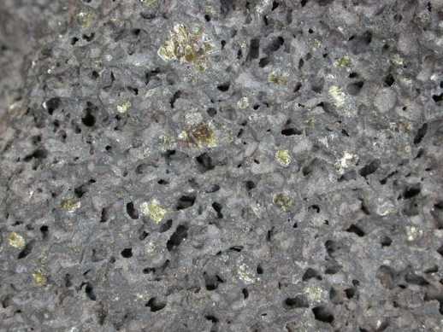

(http://www.pitt.edu/~cejones/GeoImages/2IgneousRocks/IgneousTextures/7VesicularAmygdaloidal.html)

The basalt has been estimated (using a method known as “potassium/argon dating”) to have formed between 27 and 29 million ago (Mid Tertiary age). This method is not always totally reliable and the age may have been slightly underestimated (Chalker, L. E. and Bembrick, C. S., 1976 – op. cit.).

**1.2 Meringo Creek Formation**

The Meringo Creek Formation is made up of variably consolidated quartz sandstone and pebbly sandstone that lies directly above the Coila Basalt and reaches its maximum thickness of about 45 metres approximately half way between Congo and Meringo (Rose, G., 1961 – op. cit.).

The sandstone has been deposited under fresh water, possibly in braided creeks or inland lakes and has a similar, though slightly younger, age to the basalt. Silcrete occurs in places throughout it, particularly at its base at the boundary with the underlying basalt. Silcrete is formed when water that has dissolved small amounts of silica as it percolated through the porous sediments, deposits it when the solution becomes super-saturated, commonly due to evaporation. It consists of silicified sediment, generally sandy, and is a robust material consisting entirely of silica. It was the stone material preferred by Aborigines for making flaked artefacts.

1. **Things to Look Out For**
   1. **Congo Creek**

**Spheroidal weathering in Basalt**

The small cliff at the mouth of the Congo Creek consists of weathered basalt that displays excellent examples of spheroidal weathering. “Spheroidal weathering is a form of chemical weathering that occurs when a rectangular block is weathered from three sides at the corners and from two sides along its edges. It is also called ‘onion skin’ weathering.”

(<https://www.nationalgeographic.org/encyclopedia/weathering/>)

The process causes rings of weathered rock to form progressively inwards from a fracture pattern, commonly leaving a core of less weathered or even fresh rock.

**Plate 2:** Spheroidal weathering in cliff at the

Mouth of Congo Creek.

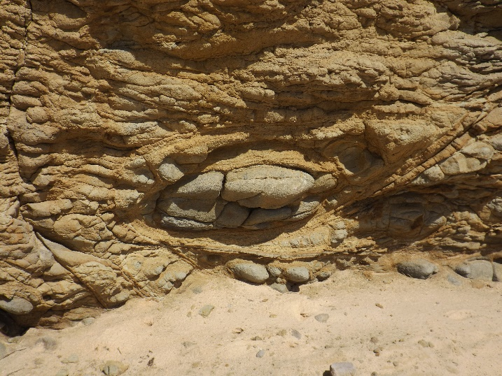

**Interlayered Amygdaloidal Basalt & Weathered Basalt**

**Plate 3:** Thin Layer of amygdaloidal basalt between

spheroidal weathered basalt layers

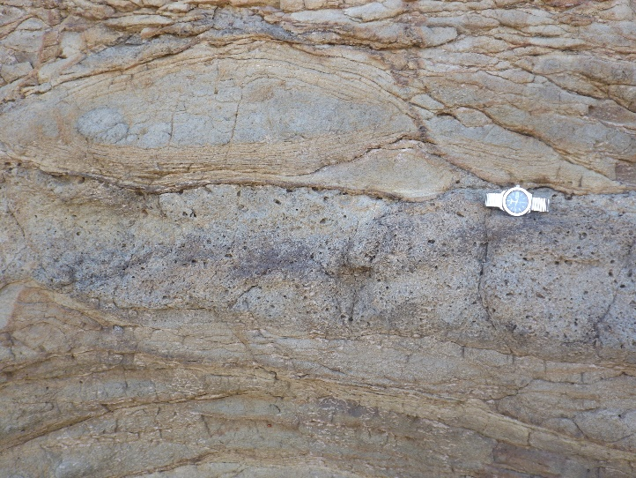

**Cliffs and Platforms**

**Plate 4:** High Tide Platform at Mouth of Congo Creek

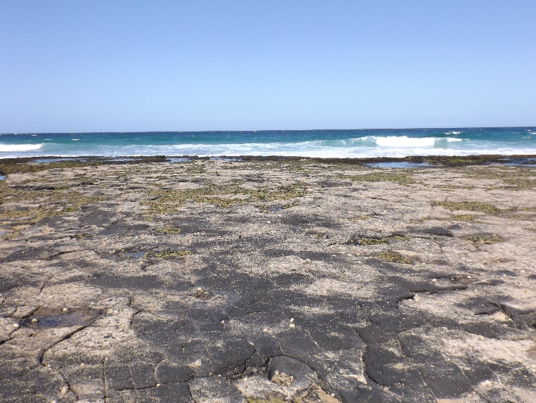

**The Origin of the Cliffs at Congo**

The steep cliffs and rock platforms at the entrance to Congo Creek/Lake are still actively forming. The degraded, partially buried ‘fossil’ cliffs to the south, adjacent to the village, are no longer active, but have the same origin as the active cliffs.

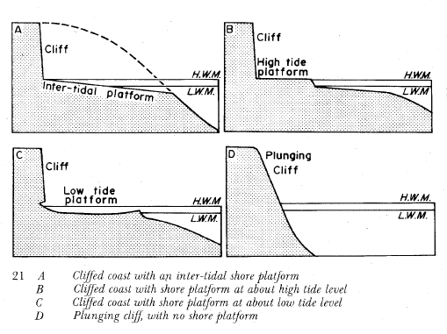

*Active cliffs and platforms*

* The platforms at Congo are high tide platforms (B in the diagram above), as are most cliffs/platforms along this part of the south coast
* Contrary to popular belief, they are not caused primarily by wave erosion
* The main cause is physical and chemical weathering of the cliff face, which causes sediment to fall down the cliff. Waves, especially storm waves, then wash away the sediment and attack and rejuvenate the base of the cliffs at the rear of the platforms
* Disintegration of the rock by weathering is not effective below high tide level where the rock is permanently saturated by sea water

(Bird, ECF 1984 *Coasts: and introduction to coastal geomorphology.* ANU Press, Canberra (3rd edition)

* 1. **Cliff South of Congo**

**Silcrete outcrop at the top of the cliff**

A large silcrete outcrop in the Meringo Creek Formation (see section 1.2 Meringo Creek Formation, above).

**Degraded ‘Fossil’ Cliffs**

* These probably formed initially during the last interglacial which peaked about 115,000 years ago when the temperature was 20 warmer and sea level 5 metres higher than today
* When the sea returned to about its present level after being 125 metres lower during the last glacial maximum there was a period somewhere between about 6 and 4,000 years ago when sea level may have been about 1 metre higher than present.
* This probably reached the base of the ‘fossil’ cliffs and cleaned away some of the weathered sediment. When the sea fell again the base of the cliffs was buried in coastal windblown sand
  1. **North Meringo Headland**

**Columnar Jointing**

Under the right condition for cooling, basalt can form vertical 5 or 6 sided columns, a feature called columnar jointing (figure 1). We will see examples of this in the cliffs on the northern end of Meringo Beach. (Plates 5 & 6)

As lava cools, it shrinks and as it becomes cold and brittle, the lava contracts and relieves the stress by cracking. The cracking produces a polygonal pattern that extends through the lava flow. As weathering cuts into lava, the rock breaks along the joints, exposing this geometric regularity. Although many of the polygons are six- sided, four, five, seven or eight sides columns are also relatively common. The degree and perfection to which this is developed depends on the thickness and composition of the lava and how fast it cools.

(<https://minds.wisconsin.edu/bitstream/handle/1793/11595/ColumnarJoints.pdf?sequence=1>)

**Figure 1:** A diagram explaining how columnar jointing

forms in a cooling body of rock,

<http://homepage.usask.ca/~mjr347/prog/geoe118/geoe118.054.html>

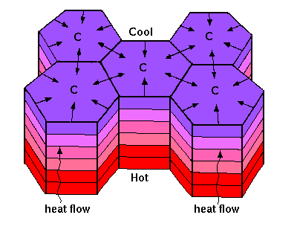

**Plate 5:** Columnar jointing in Coila Basalt at North

Meringo Headland. **Plate 6:** 4 sides of a 6-sided column fallen from the cliff at North Meringo Headland

